**FAU CEN 4010-001**

**Principles of Software Engineering**

**Summer 2023**

**Milestone 5:**

**Final Project Delivery and Demonstration**

**Team Name: The Cybernauts**

**Project Name: Memoria Web**

**Team Number: Group 12**

**GitHub Repository URL:**

[**https://github.com/BillTheKid2000/Project-Group-12**](https://github.com/BillTheKid2000/Project-Group-12)

**Team Members:**

**Billy Revelo (Team leader) -** [**brevelo2019@fau.edu**](mailto:brevelo2019@fau.edu)

**Alvaro Angeles(Scrum Master) -** [**alvaroangele2021@fau.edu**](mailto:alvaroangele2021@fau.edu)

**Andrew Ulloa (Front/Back-end developer) -** [**aulloa2017@fau.edu**](mailto:aulloa2017@fau.edu)

**Eric Pomerantz (Front/Back-end developer) -** [**epomerantz2021@fau.edu**](mailto:epomerantz2021@fau.edu)

**Shuaib Olanrewaju (Product owner/Designer) -** [**solanrewaju2020@fau.edu**](mailto:solanrewaju2020@fau.edu)

**Due Date: August 6th, 2023**

**Memoria Web's Website URL:** [**https://billthekid2000.github.io/Project-Group-12/#**](https://billthekid2000.github.io/Project-Group-12/)

**Table of Contents**

**Product Summary** 3

**Milestone Documents** 4

**Overall Feedback** 21

**Screenshots of the actual final product as shown in the demo** 22

**Google Analytics plot for your Website** 25

**Team Members Contribution** 26

**Post-Project Analysis** 27

# **Product Summary**

We are developing a virtual preservation site called 'Memoria Web,' designed to help individuals rediscover lost content from the internet. The products’ central functions include:

* Enable users to search for valuable material from the past that serves as a basis for understanding the current online landscape and discover vintage web-based content that brings forth nostalgic memories from decades past.
* Use the search engine to explore specific website links with versions dating back a decade, ensuring compatibility across all browsers and easy accessibility.
* Navigate through many forgotten historic documentations, assess the modifications of old social media sites, uncover the removal of forgotten sites and blog posts, or compare present websites sites with older versions side-by-side.

Our product is to ensure that websites, posts, and digital content are preserved for future generations to view and witness the history of the World Wide Web. This site can also prove beneficial to many upcoming software engineers who wish to learn the beginning design structures of old websites. To summarize, the Memoria web offers an entertaining and informative experience that can also appeal to many upcoming researchers looking to pursue the enigmas of forgotten online content, or for any curious individual with a lot of free time. In GitHub, we deployed all our files of code in branches, as shown in this URL link: <https://github.com/BillTheKid2000/Project-Group-12/tree/Erics-branch>.

# **Milestone Documents**

**Executive summary**

Frequently, our minds ponder the innovations made in computer-based technology and how they have advanced various forms of online content to align with the constantly evolving landscape of the internet. However, this progress has led to the complete alterations or deletions of numerous web-based material. Perchance you recall old social media platforms like YouTube or Twitter that had unique features that are no longer present today. Or maybe you recall websites, documents, or news sites that have vanished without leaving any remnants online. These thoughts ignite a desire to preserve the history of our digital footprint - a substantial platform of it started the digital forefront. For this reason, we developed the virtual preservation site, “Memoria Web.” This website is designed to allow users to search for valuable online information from the past that displays the history of the early internet scene. Using the search bar, you can traverse through selected websites and identify old online content that evokes nostalgic memories from decades prior. Navigate through many forgotten historic documentations, assess the modifications of old social media sites, uncover the removal of forgotten sites and blog posts, or compare present websites sites with older versions side-by-side. Our product is to ensure that websites, posts, and digital content are preserved for future generations to view and witness the history of the World Wide Web. This site can also prove beneficial to many upcoming software engineers who wish to learn the beginning design structures of old websites. To summarize, the Memoria web offers an entertaining and informative experience that can also appeal to many upcoming researchers looking to pursue the enigmas of forgotten online content, or for any curious individual with a lot of free time.

**Competitive analysis**

|  |  |  |  |  |
| --- | --- | --- | --- | --- |
|  | **Memoria Web** | **Internet Archive** | **Library of Congress** | **Archive.today** |
| **Homepage** | **5** | **5** | **5** | **3** |
| **GUI Design** | **5** | **4** | **4** | **3** |
| **Search** | **4** | **5** | **5** | **4** |
| **FAQ** | **5** | **5** | **5** | **5** |
| **Content** | **4** | **5** | **5** | **4** |
| **Login** | **5** | **5** | **0** | **0** |
| **Navigation** | **5** | **4** | **5** | **4** |
| **Snapshots** | **0** | **0** | **0** | **5** |
| **Mean** | **4.13** | **4.13** | **3.63** | **3.5** |

**Target audience:** The *Memoria Web* is directed at people interested in what internet pages looked like in the past for the sake of nostalgic satisfaction, research purposes, curiosity or competitive analysis for web developers who want to analyze the changes in design considerations overtime. The table provided below compares three competitor websites to differentiate their key features for archiving past internet sites. This table is structured into eight categories, each assigned a rating scale ranging from 1 to 5 (1 = N/A, 2 = executed poorly, 3 = executed fairly, 4 = executed good, 5 = executed greatly).

**Competitors:** This is a very niche market that could benefit from decentralization. From here, we will discuss the competitors’ fundamental details of the sites.

1. **Internet Archive**

*[“Internet Archive](https://archive.org/)* is a non-profit library of millions of free books, movies, software, music, websites, and more.” (“Internet Archive: Digital Library of Free & Borrowable Books, Movies ...”) Various subsidiaries stem and source information from here due to the vastness of content availability.

1. **Library of Congress**

[Library of congress](https://www.loc.gov/web-archives/) TheLibrary of Congress Web Archive manages, preserves, and provides access to archived web content selected by subject experts from across the library, so that it will be available for researchers today and in the future.

1. **Archive.today**

[Archive.today](http://archive.today/) is a time capsule for web pages. It takes a 'snapshot' of a webpage that will always be online even if the original page disappears. It saves a text and a graphical copy of the page for better accuracy and provides a short and reliable link to an unalterable record of any web page. (“Webpage archive”)

**Competitive advantage:** The focal point of *Memoria Web* is its simplified user-experience which would be an easy to navigate and concise form of *content* delivery due to its simplicity and minimalist designwhich would be better suited for use on mobile touchscreen devices. By focusing on prescribed dates and sites rather than the added complexity of result filtering, it would require less input from the user to interact and access.

**Data definition**

|  |  |  |
| --- | --- | --- |
| **Name** | **Meaning** | **Usage** |
| **Memoria Web** | Service / Online Archive Website | Used when referring to the website that we are developing to archive past content online for the present. |
| **Memoria** | The Latin word for memory. | This term describes memory characteristics in the context of time-related expressions on the internet. |
| **Archive** | Online service for holding pieces of informative internet material. | This term emphasizes the extensive size of internet data carefully preserved for future purposes. |
| **Researcher** | Actor / someone uncovering information in their field of work. | Used to refer to an intellectual who searches for information from old web pages using the website. |
| **Software Engineer** | Actor / Workers who utilizes the engineering design process for computer software. | Used to refer to an individual who utilizes the website for information about the design structure in old sites. |
| **FAQ** | Acronym for “Frequently Asked Questions.” | Used to refer to a list of queries and answers pertaining to specific topics and fundamental information about the website aimed for users. |
| **Benefits** | Online service for highlighting benefits about the site. | Used to describe the goals of the site that uses will find valuable online. |
| **Users** | Actors / Individuals who utilize the website out of genuine curiosity or for academic purposes. | Used to refer to individuals that are searching for old online content when utilizing the website. |
| **Main page** | The main user interface enables users to navigate through past and forgotten content. | Used to refer to the homepage of the website for the users to start their discoveries. |
| **Search Bar** | Site service that allows the navigation of content in the main webpage. | Used to refer to the navigation tool that allows for searching various content long past forgotten. |
| **Login** | Service that acts as a form of logging into a computer, system, database, or online registry. | Utilized for users to sign into the website that allows for the best experience in locating archived information on the internet. |
| **Member** | Actors / Individuals who utilize the login to receive more features on the website | Describes a community of registered users who intend to access and utilize the various features offered by the website. |
| **News sites** | Web page that serves to document news related content locally or internationally. | Used to refer to the web pages that allow users to search for historic events and news coverage from a decade ago. |
| **Social media** | Web page that displays versions of popular sites for social interaction. | Used to refer to web pages that hold past media networks where users can interact with old previous versions of the site. |
| **Blog posts** | Web page that highlights archived forums and general posts from the community. | Used to refer to old community forums from deleted blogs that shared interactions from ten years ago. |
| **Website** | A collection of related web pages organized together in one location. | Used by individuals on the internet to gather data or spread information. |
| **Time capsule** | A space that stores historical records or objects representing past achievements for preservation until they are discovered by future generations. | Used to refer to the website’s goal of preserving past and lost material from the internet for many future generations to view. |
| **Navigate** | Action to look around the sections in a website for content available. | Used by users of a website in a quest to locate a specific section online. |
| **URL** | Acronym for “Uniform Resource Locator.” | Utilized by website users in their pursuit to locate a particular site on the internet. |

**Overview, Scenarios and Use Cases**

*Memoria Web* is a web application that allows users to journey back in time and explore archived versions of websites from the past. Whether it is for nostalgic purposes, retrieving lost information, or studying the evolution of web design and software practices, this application provides a unique and immersive experience. Users of all skill levels can easily access and navigate through archived web pages, enabling them to witness the digital history unfold before their eyes. The main use-cases includes:

1. **Nostalgic Expedition:**

Imagine someone in their early twenties or late thirties, feeling nostalgic for their favorite online community board that existed a decade ago. Curious to revisit the discussions, memories, and shared experiences, they turn to *Memoria Web.* With a simple search, they discover a preserved version of the long-gone forums. They can now immerse themselves in the past, reliving the solidarity and excitement of their youth, as if the forum were still active today.

1. **Retrieving Abandon Information:**

Consider a resolute researcher working on a project that requires accessing information from a website that no longer exists. Frustrated by the dead-end links and error messages, they stumble upon *Memoria Web*. By utilizing the application's extensive archive, they manage to locate the desired website and retrieve valuable data. With this newfound resource, they can complete their research and present their findings.

1. **Comparative Analysis of Content for Software Engineers:**

Think about a software engineer that is working on a project to revamp a legacy system. They want to study the visual aspects, user interfaces, and software practices of similar systems from the past to understand their evolution. Memoria Web becomes their time capsule, enabling them to compare the past and present pages side by side. They can delve into archived websites, examine the various design structures, and gather insights that inform their modern development strategies.

*Memoria Web* offers an exquisite opportunity for users to embark on a captivating journey through digital history. With the ability to relive the past, retrieve lost information, and conduct comparative analysis, users of all skill levels can engage with archived web pages to fulfill their individual needs. By preserving the ever-changing online landscape, this application opens a gateway to the past, providing a valuable resource for education, research, and personal nostalgia.

**Initial List of High-level Functional Requirements**

For this project, we have written a list of both functional and nonfunctional requirements. Both need to be known by the production team for everyone to know exactly how to build said project. In this section, we will be looking at some functional requirements for “Memoria Web.” Functional requirements cover anything a system should provide to the user, how it should behave with any interactions, and the system's overall function. We categorize every requirement into three prioritization levels (Priority 1 = essential/must-have, Priority 2 = preferred/desired, Priority 3 = optional/opportunistic) as per the definitions defined in class.

* **Priority 1:** There is to be a title at the top of the main page stating, “Memoria Web,” with an active search bar for navigation to the various contents.
* **Priority 2:** Our logo is to be present next to the main page title without any visual errors.
* **Priority 2:** Underneath the main page title should lay a concise description of the site’s overall goals.
* **Priority 3:** It is necessary for the website to be short enough in height, guaranteeing that users do not have to scroll too far down to view all archived sites.
* **Priority 2:** There should be at least 10 websites to monitor.
* **Priority 2:** Each tracked site must state its name, date, and logo.
* **Priority 1:** Every link to a tracked site must lead to said site in its past respective year.
* **Priority 2:** At the bottom of the main page, there should be a copyright description and citations for the external services used for that site.

First, some specifics required for the project design are the title, logo, intention description, and footer copyright. These are the vital elements that make our product stand out to the user. Core elements that are also functional requirements are at least 10 tracked sites, each having a name and logo, a direct link to said site, and for the project site to be small enough so that the user does not have to scroll at all. The production of our project site will be made revolving around these key traits, as they guide us on our final vision.

**List of Non-functional Requirements**

Just like there are functional requirements needed to guide a production team through design, there are also nonfunctional requirements that are more important to the success of the overall project. This section concerns the nonfunctional requirements for our “Memoria Web” project, revolving around the idea of understanding development “constraints” and “limitations.” Some examples may include time, process, or standard constraints. These elements focus on the project, and not just one section.

* **Priority 2:** The website must be easy to understand and acceptable for all types of users.
* **Priority 2:** Site downtime must not exceed 10 minutes in total out of the 5 weekdays.
* **Priority 1:** The site must be compatible with modern browsers such as Google Chrome, Mozilla Firefox, Oracle Opera, and Apple Safari.
* **Priority 2:** Total website and project size must not exceed 5 gigabytes (5GB).
* **Priority 2:** Response timing on user clicks and its reaction must not exceed 5 seconds.
* **Priority 1:** The programming languages must include HTML, CSS (Cascading Style Sheets), and / or Bootstrap programming.

To start, the project website must be easy to understand for inexperienced users. Therefore, there must not be any complex functions or elements shown in the user interface. It must also have an uptime with high reliability, as it cannot exceed 10 minutes of downtime in total out of any week in a year. To go along with these constraints, we also agreed to make it compatible with most of the popular internet browsers, as well as to make it lightweight of less than 5 gigabytes. Response timing on clicks will not exceed 5 seconds, and the complete site must be limited to HTML, CSS, Bootstrap, and (electively) JavaScript.

**High-level System Architecture**

1. **Software Products:**

**Web Development Framework:** We will use frameworks like *Firebase* to create a responsive front-end. Given the historical and nostalgia-inducing nature of our project, it is crucial to design a user interface that can adapt to a variety of devices, from desktop to mobile. We decided to not utilize bootstrap in any way due to lack of reliability with this framework.

**Hosting Service:** We'll deploy the application on Firebase, which will always ensure our historical data’s accessibility, contributing to the project's mission of preserving online history.

**GitHub**: GitHub will serve as our collaborative hub where we will store all our files in one location and share them among our team. As our project relates to digital history, it is essential that we also maintain a thorough history of our own development process. We can utilize the desktop application GitHub to update the codes by linking it to *Visual Studio Code.*

1. **Tools:**

**Version Control System (VCS):** *Git* will allow us to track changes in our codebase over time, paralleling our goal of tracking changes made in the online world.

**Bug Tracking System:** We'll use GitHub's issue tracking, ensuring our web portal's reliability as a resource for historical online data without any issues or bugs.

**Continuous Integration (CI) and Continuous Delivery (CD) tools:** Leveraging the *CI/CD* capabilities of ***Visual Studio Code*** and ***Firebase***, we will ensure a smooth and continuous delivery of updates, enhancing the accuracy and reliability of our program that archives the historical online content over time.

1. **Languages:**

**Front-end Language:** Programming languages like *HTML* and *CSS* will be utilized to create an inviting, user-friendly, and historically minded interface. We decided not to utilize bootstrap since our group is much more accustomed to the other languages.

**Back-end Language:** We'll use JavaScript for interactive client-side operations and Python for server-side logic to oversee the complex operations of sourcing and presenting historical web data.

1. **Systems:**

**Operating System:** Our platform will be OS-agnostic, just like the web itself. Most well-known operating systems include *Windows, macOS,* and *Linux.*

**Database:** Databases*PostgreSQL* or *MySQL* will help us efficiently store and manage the vast amount of historical data necessary for our project.

1. **Core APIs:**

**HTTP, JSON, and XML APIs:** These APIs will enable us to interact with and retrieve data from various online sources, crucial for aggregating the historical data we present. We also referenced these specific APIs as they are utilized in the Wayback Machines API that we employed as the foundation to how our website would run.

**Further explanations of specific APIs:** At present, we have engaged in a discussion about utilizing the AJAX (Asynchronous JavaScript and XML) API to implement the coding for our website. However, we have not reached a definitive decision yet; nevertheless, we have documented the idea for further consideration. As of now, we are prioritizing the Wayback Machine’s API for our code.

* **AJAX** **(Asynchronous JavaScript and XML API):** This API enables real-time updates of information displayed on forms, eliminating the need to reload the entire page when running.

1. **Supported Browsers:**

Our project will be compatible with all major browsers, including *Chrome, Firefox, Safari,* and *Edge*. We will be mirroring the universal accessibility that has been a cornerstone of the web's design from its inception.

1. **Frameworks:**

The website could be built using a variety of front-end or back-end frameworks. The choice of framework will be dependent on the specific requirements for our project. After careful consideration of the types of frameworks, we decided not to use *Flask* or *Django*. The reason for this is due to the group wishing to utilize *Firebase* and *JavaScript* to ensure effective server-side operations, assisting us in acquiring reliable data.

1. **User Interface:**

The user interface (UI) of the website should be designed to be user-friendly and easy to navigate. The UI should be consistent across all browsers and devices.

1. **Cross-Platform and Cross-Browser Layout/CSS:**

To represent the web's history accurately, our website will have a consistent look and feel across all platforms and browsers, achieved via responsive design and cross-browser compatibility using *Cascading Style Sheets* (CSS).

1. **External Code:**

We may use external libraries or plugins to enhance functionality, ensuring we can provide a rich, historical browsing experience that accurately represents the online web's past state.

**High Level UML Diagrams**

**High level UML Class Diagram:**

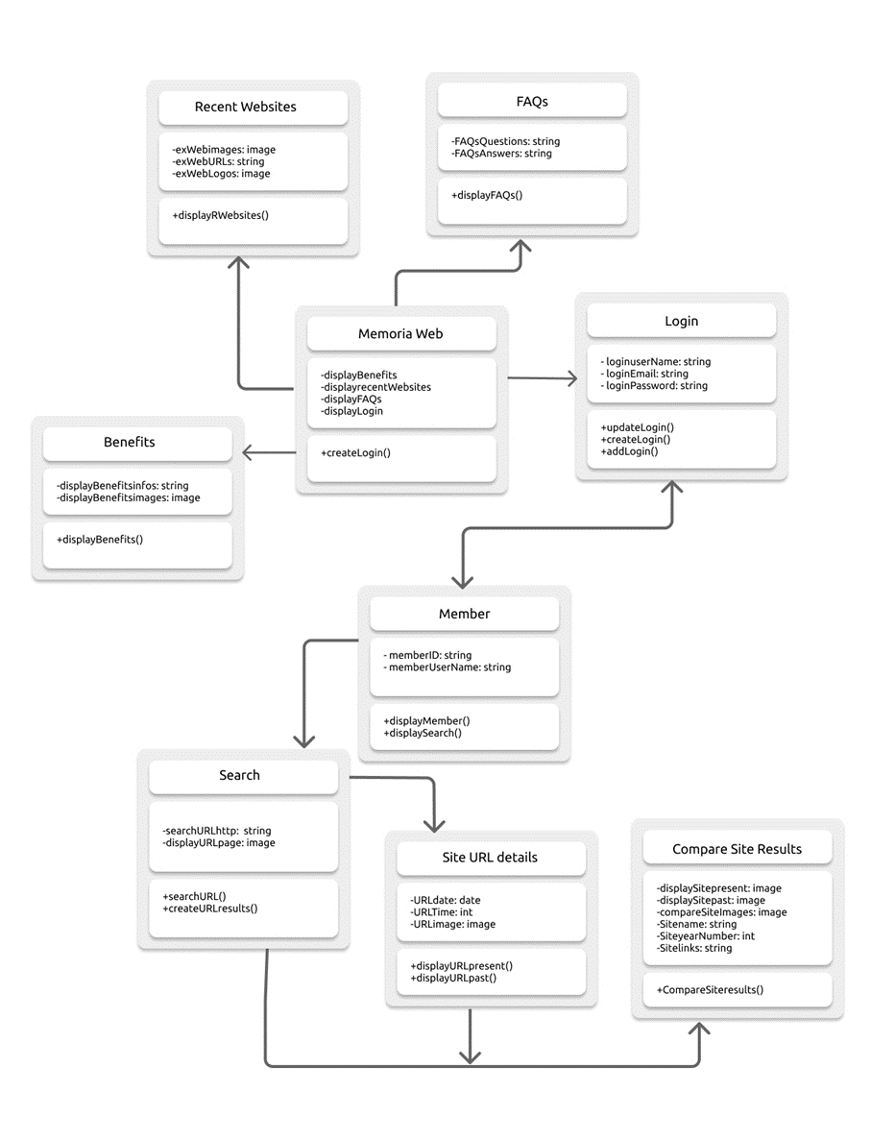

**High level UML Component Diagram:**

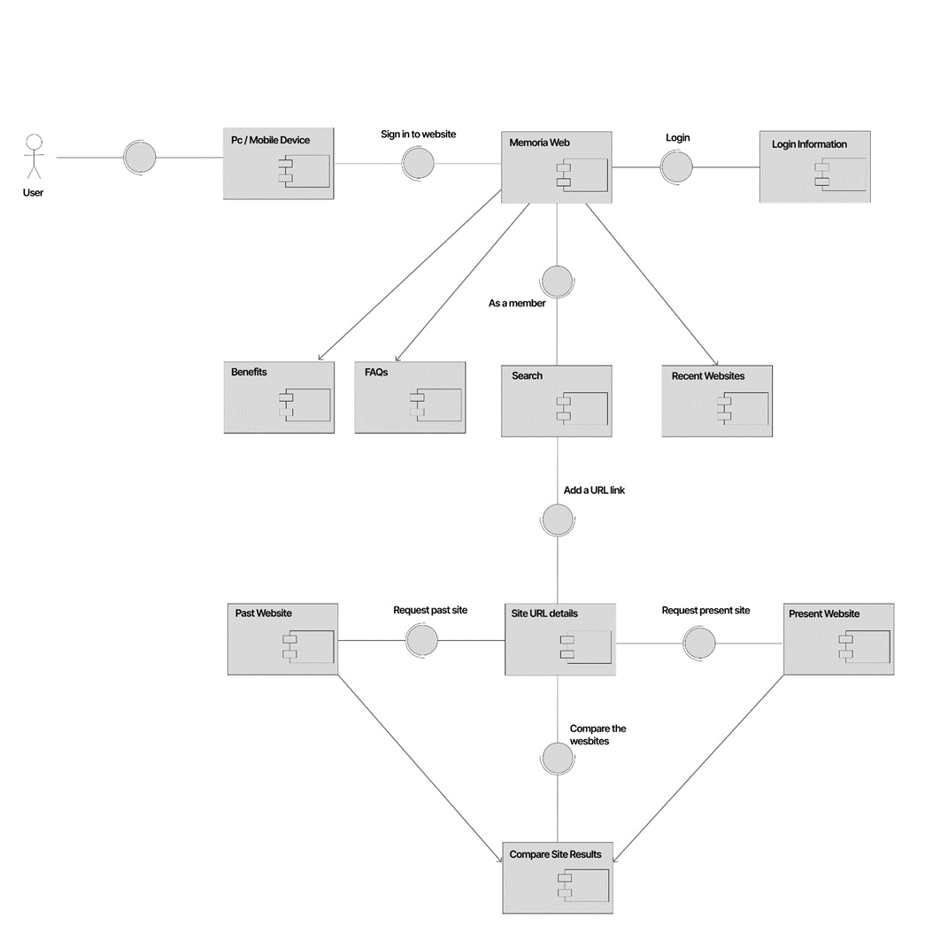

**High level UML Deployment Diagram:**

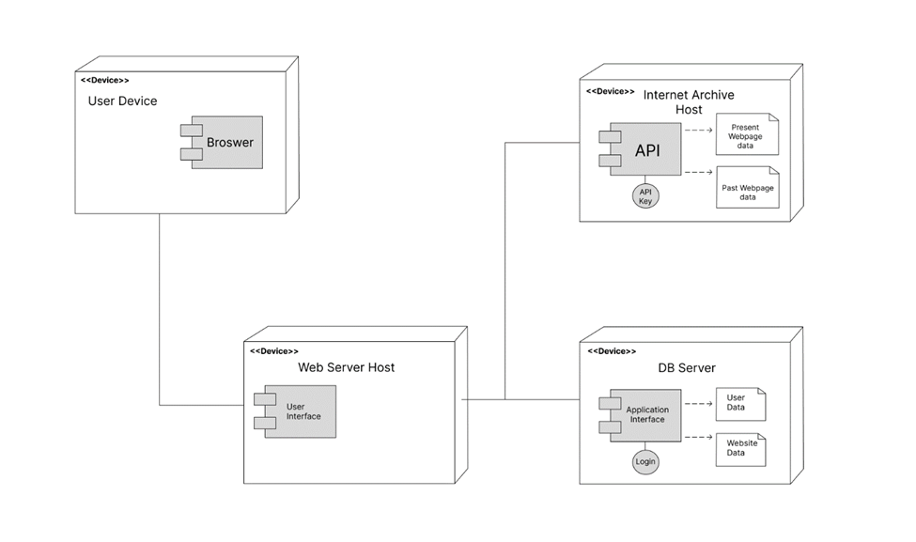

**Actual Key Risks for Project currently**

1. **Skill Risks:**

**Problem:** Lack of knowledge to structure the code to match the design of our GUI mockup design.

**Solution:** Leveraging their expertise in JavaScript coding, our two front-end and back-end developers, Alvaro Angeles, Andrew Ulloa, and Eric Pomerantz, worked diligently to ensure that the website's output aligned perfectly with our envisioned display for the website.

1. **Schedule Risks:**

**Problem:** Initially, devising a work structure to meet the deadlines posed a challenge for creating the vertical prototype and updated Milestone document.

**Solution:** To streamline our efforts into the prototype and document, we agreed on specific periods for daily meetups when all team members were available to assist each other as needed. These meetups are organized and notified by our team leader, Billy Revelo, who outlines the tasks for the two groups to be initiated and completed during each session.

1. **Technical Risks:**

**Problem:** Most of our group members did not know how to operate tools from the Figma site.

**Solution:** Andrew Ulloa, a member of our group, expertly operated the Figma tools and skillfully instructed the rest of the team on using these tools to design the GUI mockup design and UML diagrams.

1. **Teamwork Risks:**

**Problem:** As our team is divided into smaller groups to determine the roles for the project, we faced a challenge where some members may be unavailable due to personal reasons, potentially leaving the group without sufficient resources.

**Solution:** We established a Discord group with various channels, providing an open platform for anyone to join and seek aid or inform us about their availability. Additionally, we utilized *GitHub* to track and store files from the group’s work in case a team member is unable to participate on a particular day.

1. **Legal / Content Risks:**

**Problem:** We opted to shorten our product's name from 'The Cyber Nostalgia Capsule' to 'Memoria Web’ to ensure simplicity and uniqueness. Nevertheless, we recently discovered that this name bears resemblance to a Hispanic website specializing in developing and coordinating exhibition projects.

**Solution:** Fortunately, we can ensure that there are no legal copyright issues since our website is entirely distinct from the other site. Our core focus is on encapsulating forgotten online content, not organizing art shows.

**Checklist**

| **Review** | **Status** | **Notes** |
| --- | --- | --- |
| **Team decided on basic means of communications** | DONE |  |
| **Team found a time slot to meet outside of the class** | DONE |  |
| **Front-end and Back-end team leads chosen** | DONE |  |
| **GitHub master chosen** | DONE |  |
| **Team ready and able to use the chosen back and front-end frameworks** | DONE |  |
| **Skills of each team member defined and known to all** | DONE |  |
| **Team lead ensured that all team members read the final M1 and agree/understand it before submission** | DONE |  |

## **Overall Feedback**

We received minimal constructive feedback for Milestones 3 and 4, leading our team to believe that the work accomplished during that period was exceptionally well-executed. Despite the absence of feedback, it remained crucial for us to ensure that our project's top priorities were in focus and that we effectively managed our time and resources.

# **Screenshots of the actual final product as shown in the demo**

**Product Screenshots:**

1. **Main Page**

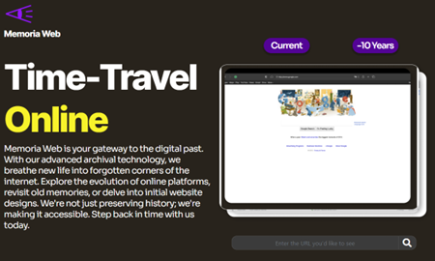

1. **Sign-up Option**

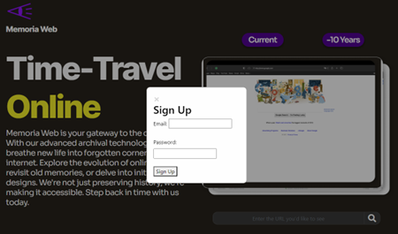

1. **Sign-in Option**

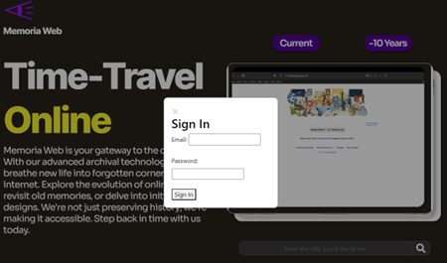

1. **Custom Search option (Present)**

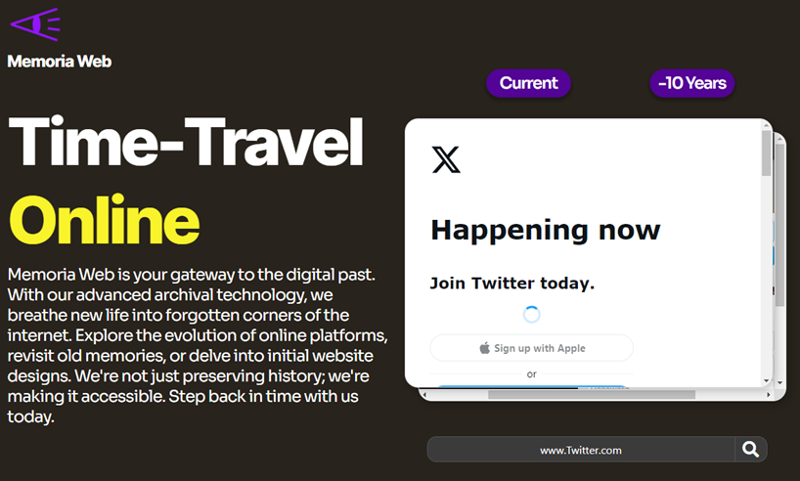

1. **Custom Search option (Present)**

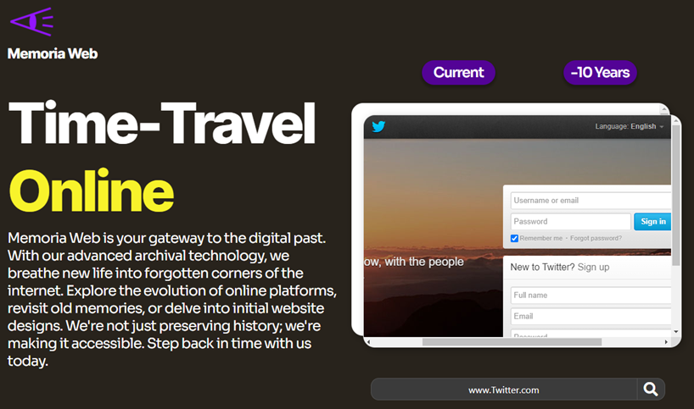

# **Google Analytics plot for your Website**

We utilized Google Analytics for web traffic of the website using the Firebase overview. This image highlights the main web traffic of the website itself. Our team established user activity on the website over time, with a substantial portion of the views generated by each member for reviewing the design and functionality. We managed the overall website across the country as shown in the web traffic. The usability of the website contributed quite well on the standard browsers and on mobile, although for some reason it was not directly displayed on the main page of the analytics.

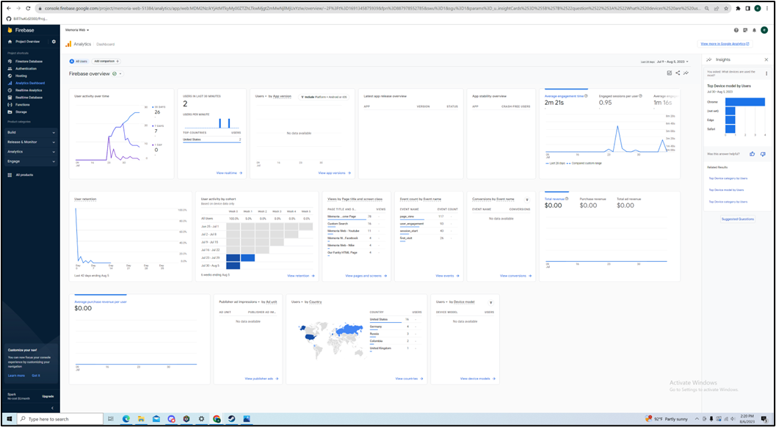

# **Team Members Contribution**

Throughout the project's period, our team was organized into distinct groups, each responsible for handling distinct aspects of the project. Each team member played a role in many major aspects, utilizing their assigned responsibilities to contribute to the website's development. The contributions from the team members are listed below:

* Billy Revelo (Team leader): (20/20)
  + Billy held the responsibility of overseeing tasks focused on ensuring efficient communication, collaboration, and successful project delivery.
* Alvaro Angeles (scrum Master): (20/20)
  + Alvaro was the one to keep track of the scrum meetings through discord meetings and remove any unnecessary external obstacles in our way.
* Andrew Ulloa (Front/Back-end Developer): (20/20)
  + Andrew oversaw the GUI design development with Eric working on the code's functional and nonfunction requirements.
* Eric Pomerantz (Front/Back-end Developer): (20/20)
  + Eric has been very prominent in developing the main function of the code that allows the search and link functions to operate smoothly as possible.
* Shuaib Olanrewaju (Product Owner/Designer): (20/20)
  + Shuaib took on the responsibility of identifying user needs and core objectives to define our product's core. He also played a role in documenting the tasks of our website and tracking our ongoing progress.

# **Post-Project Analysis**

During the initial phases, the team discussed minor details such as the project's definitive name and overall features. The inspiration behind Memoria Web's functionalities was to display and navigate long-forgotten content online. However, the actual implementation of these ideas and the coding process turned out to be more time-consuming than anticipated. Most of the web design was successfully integrated into the GUI mockup using Figma, but we faced difficulties in implementing many of the functions into the actual website. Fortunately, our front-end and back-end developers were skilled in incorporating these frameworks / APIs into the project, with resources aided by competitor sites like the Wayback Machine. The work of the two developers was distributed on GitHub, and they exchanged the code for each implemented feature to be reviewed and contributed by the other team members. The team leader and scrum master actively contributed to organizing meetings to discuss employed tasks for each team member, prioritize essential features to meet deadlines, and evaluate project design and documentation at every milestone. Approaching the project’s deadline, major portions of the top priorities were completed, including the implementation of the custom search bar and the display of the side-by-side comparisons of past and present online content. The only minor aspects that remained unresolved were the prolonged loading time of the search option and the debugging of the main page. Entering the URL into the search bar resulted in a notably long loading time for displaying the outputs. Our team tried to mitigate this matter yet finding a solution to speed up the process proved tricky, despite it being one of the key priorities during the initial development phase. Another issue occurred when we tried to update front end design with bootstrap. Some essential code for firebase got edited and/or deleted by the IDE. Because of this, we scrapped some of the interactive links to the different sections of the main page. If we had more time on the project, we believe we could have found a solution to fix most of our technical errors. In conclusion, we have taken valuable lessons from this experience and are committed to improving our contributions to future projects through more effective scheduling and time management.